**A**

**Project Report on**

# CRYPTOCURRENCY TRADING PLATFORM

**Submitted by**

**B.Shanthi-R190664**

**P.Udayasilpa-R190077**

**Under the guidance of**

**Dr. K .Vinod Kumar, M .Tech, Ph.D**

**Assistant Professor**

## Department of Computer Science and Engineering



**Rajiv Gandhi University of Knowledge Technologies (RGUKT) R K Valley, Y.S.R. Kadapa, Andhra Pradesh**

### RAJIV GANDHI UNIVERSITY OF KNOWLEDGE

### AND TECHNOLOGIES

### (A.P.Government Act 18 of 2008 )

### RGUKT IIIT RK Valley

**Vempalli, Kadapa, Andhra Pradesh – 516330.**

# CERTIFICATE OF PROJECT COMPLETION

This is to certify that I have examined the thesis entitled “**Cryptocurrency Trading Platform**” submitted by **B.Shanthi (R190664) and P.Udayasilpa (R190077)** under our guidance and supervision for the partial fulfilment for the degree of Bachelor of Technology in computer Science and Engineering during the academic session August 2024 - November 2024 at RGUKTRKVALLEY. To the best of my knowledge, the results embodied in this dissertation work have not been submitted to any university or institute for the award of any degree or diploma.

## Project Guide Head of the Department (CSE)

Dr. K Vinod Kumar, Dr. Ch. Ratna Kumari,

. Asst. Prof. in Dept of CSE, Asst. Prof. in Dept of CSE,

RGUKT-RK Valley. RGUKT-RK Valley.

### RAJIV GANDHI UNIVERSITY OF KNOWLEDGE

### AND TECHNOLOGIES

### (A.P.Government Act 18 of 2008 )

### RGUKT IIIT RK Valley

**Vempalli, Kadapa, Andhra Pradesh – 516330.**

# DECLARATION

I, P.Udayasilpa (R190077) hereby declare that the project report entitled

“**Cryptocurrency** **Trading Platform**” done by us under guidance of **Dr. K Vinod Kumar** is submitted in partial fulfillment for the degree of Bachelor of Technology in Computer Science and Engineering during the academic session August 2024 – November 2024 at RGUKT-RK Valley. I also declare that this project is a result of my own effort and has not been copied or imitated from any source. Citations from websites are mentioned in the references. To the best of my knowledge, the results embodied in this dissertation work have not been submitted to any university or institute for the award of any degree or diploma.

**Date : P.Udayasilpa-R190077**

**Place : RGUKT,RK Valley**

# ACKNOWLEDGEMENT

I would like to express my sense of gratitude and respect to all those people behind the screen who guided, inspired and helped me to crown all our efforts with success. I wish to express my gratitude to my project coordinator **Dr. K Vinod Kumar** for his valuable guidance at all stages of study, advice, constructive suggestions, supportive attitude and continuous encouragement, without which this project could not be possible.

I would also like to extend our deepest gratitude and reverence to the Head of Department of Computer Science and Engineering **Dr. CH. Ratna Kumari** and also Director of RGUKT, RK Valley prof**. Dr. A V S S Kumara Swami Gupta** for their constant support and encouragement.

Last but not least I express my gratitude to my parents for their constant source of encouragement and inspiration for me to keep my morals high.

**With Sincere Regards,**

P.Udayasilpa(R190077)

B.Shanthi(R190664)

**Table of Contents**

|  |  |  |
| --- | --- | --- |
| **S.No.** | **Index** | **Page Number** |
|  | Abstract | 6 |
|  | List of Figures | 7 |
| 1. | Introduction  1.1 Problem Statement  1.2 Motivation  1.3 Contribution | 8-11 |
| 2. | Literature Review | 12-14 |
| 3. | Modules  Module-3.1:  Module-3.2:  Module-3.3: | 15-18  19-25  26-28 |
| 4. | Results and Discussion | 29-30 |
| 5. | Conclusion and Future Enhancement | 31 |
| 6. | References | 32 |

## ABSTRACT

The rapid growth of cryptocurrency markets has necessitated secure, user-friendly platforms to facilitate trading while addressing concerns of transparency, usability, and scalability. This project proposes the development of a Cryptocurrency Trading Platform leveraging Spring Boot for the backend and React.js for the frontend. The platform aims to provide a seamless and secure trading experience for users by integrating modern features and robust architecture.

Key functionalities include Two-Factor Authentication (2FA) by sending OTPs to users' registered email addresses, ensuring secure access. The platform displays real-time data of the top 50 cryptocurrencies, including their market capitalization, current price, trading volume, and price fluctuations, visualized through dynamic graphs for informed decision-making. Users can engage in cryptocurrency trading with an intuitive interface that supports buying and selling, while maintaining a detailed trading history and an integrated wallet for managing assets.

To enhance user experience, the platform incorporates a chatbot feature that provides instant responses to cryptocurrency-related inquiries, offering educational and technical support. By combining advanced backend logic with a responsive frontend, the platform ensures high performance and scalability, meeting the needs of both novice and experienced traders in the rapidly evolving crypto ecosystem. This project addresses the critical challenges of security, usability, and real-time data integration in cryptocurrency trading.

## 

## LIST OF FIGURES

|  |  |  |
| --- | --- | --- |
| **Figure No** | **Title** | **Page No** |
| Figure 1 | Working Flow of Project | 20 |
| Figure 2 | Registration Page | 23 |
| Figure 3 | Two Step Verification | 24 |
| Figure 4 | Home Page | 25 |
| Figure 5 | Application Properties | 27 |
| Figure 6 | Backend dependencies | 27 |
| Figure 7 | Watchlist | 28 |

# 1. INTRODUCTION

## 1.1 Problem Statements

Cryptocurrency trading platforms face significant security challenges as the popularity of digital assets continues to rise. Without robust security measures, user accounts and transactions are vulnerable to unauthorized access and fraud. Implementing Two-Factor Authentication (2FA) using email OTPs can enhance account protection and build trust among users by addressing these critical security concerns. Another pressing issue is the lack of real-time data and market insights available to traders. Many platforms fail to provide up-to-date information about cryptocurrencies, making it difficult for users to make informed decisions. Displaying comprehensive data on the top 50 cryptocurrencies, including their market capitalization, price, volume, and price fluctuations, supported by graphical representations, can empower traders with actionable insights and improve their trading strategies.

The complexity of trading operations is another hurdle that discourages new users and frustrates experienced traders. Platforms often have complicated interfaces that make buying, selling, and managing assets cumbersome. Simplifying these operations while offering detailed trading history is essential to improving user experience and encouraging wider adoption. Efficient management of cryptocurrency holdings is a significant challenge due to the absence of well-integrated tools. An integrated wallet is critical for providing users with a secure and convenient way to manage their assets, track balances, and conduct transactions without the need for third-party tools.

Additionally, the lack of immediate assistance is a major drawback on many platforms. Novice traders often have questions or require guidance while navigating the complexities of cryptocurrency trading. Incorporating a chatbot capable of providing instant answers to cryptocurrency-related queries can significantly improve user satisfaction and reduce onboarding barriers. From a technical perspective, many trading platforms struggle with scalability and performance issues, especially as trading volumes increase. To meet these demands, the backend architecture must be designed for high performance and reliability. Using Spring Boot for backend development offers a robust foundation to address these challenges effectively.

On the front end, usability is often overlooked, leading to interfaces that are unresponsive or difficult to navigate. Leveraging React.js for frontend development can deliver an interactive and user-friendly interface that caters to traders of all experience levels, ensuring a smooth and engaging experience. This project seeks to resolve these challenges by integrating innovative features and technologies, delivering a secure, efficient, and user-centric cryptocurrency trading platform.

## 1.2 Motivation

The motivation behind developing a Cryptocurrency Trading Platform stems from the rapid growth and global adoption of cryptocurrencies as a revolutionary form of digital asset. As the demand for cryptocurrency trading rises, there is an increasing need for a secure, efficient, and user-friendly platform that caters to both novice and experienced traders. This project seeks to address these gaps by providing a comprehensive solution that empowers users to participate in the dynamic cryptocurrency market confidently and effectively.

Security is a paramount concern in cryptocurrency trading, with numerous instances of hacks and unauthorized access in existing platforms. Users need assurance that their accounts and transactions are safe. This drives the integration of Two-Factor Authentication (2FA), using OTPs sent to email for secure login, ensuring peace of mind for traders and protecting their digital assets from unauthorized access.

Another key motivation is the need for real-time market insights. In the volatile world of cryptocurrencies, traders require access to accurate, up-to-date data to make informed decisions. By providing detailed information on the top 50 cryptocurrencies, including market capitalization, price, volume, and price fluctuations with graphical visualizations, the platform enables users to analyze trends and make data-driven trading decisions.

Finally, transparency and trustworthiness are crucial in this industry. By addressing challenges such as regulatory compliance and operational transparency, the platform can foster trust and credibility, attracting a broader user base.This project is driven by the vision of creating a secure, user-centric, and technologically advanced platform that not only addresses current limitations but also sets a new standard in cryptocurrency trading.

### 1.3 Contribution

The Cryptocurrency Trading Platform project offers several key contributions to society, particularly in the areas of financial inclusion, security, transparency, and user empowerment within the cryptocurrency market. These contributions can have a lasting positive impact on the way individuals and communities engage with digital assets.

Security is a critical issue in the cryptocurrency space, and this project addresses it by implementing Two-Factor Authentication (2FA) with email-based OTPs, protecting users from unauthorized access and fraud. By prioritizing security, the platform helps build trust among users, promoting safe practices in cryptocurrency trading. As cryptocurrency adoption continues to rise, a secure platform helps mitigate risks associated with digital asset theft or hacking, fostering greater trust in the digital economy.

By providing real-time data about the top 50 cryptocurrencies, including their market cap, price, and volume, the platform promotes transparency in the cryptocurrency market. Users can access comprehensive information and track price fluctuations, which is crucial for fostering an environment of fairness and openness in an often volatile market. This contributes to a more transparent financial ecosystem, where users can make decisions based on accurate, up-to-date information.

This Cryptocurrency Trading Platform project contributes to society by promoting financial inclusion, security, education, and transparency in the cryptocurrency market. It helps individuals engage with digital assets more responsibly while fostering trust and empowering them with the knowledge and tools necessary to succeed in the evolving world of digital finance.

## 2. LITERATURE REVIEW

### 2.1 Existing System

**Security Measures:**

Most existing cryptocurrency trading platforms implement basic security protocols such as password-based authentication. However, many fail to provide robust Two-Factor Authentication (2FA) mechanisms, leaving users vulnerable to cyberattacks and unauthorized access

**Data Accessibility and Visualization:**

Existing platforms typically display market data, but the information is often scattered or lacks real-time accuracy. Some systems provide raw numerical data but fail to offer interactive graphs or visualizations, making it difficult for users to interpret market trends and fluctuations effectively.

**User Interface and Experience:**

Many platforms prioritize advanced features over usability, leading to interfaces that are unintuitive for novice users. Complex navigation and cluttered dashboards can overwhelm beginners, limiting their ability to trade confidently.

**Cryptocurrency Education and Support:**

Current systems often lack adequate support features for educating users about cryptocurrencies. Most platforms rely on static FAQs or customer service tickets, which are neither immediate nor interactive, leaving users without real-time assistance.

**Wallet and Transaction Management:**

While integrated wallets are a feature of many platforms, they often lack seamless portfolio management tools. Tracking trading history and managing balances across different cryptocurrencies can be tedious and prone to errors.

**Scalability and Performance:**

As the popularity of cryptocurrency trading grows, many platforms struggle with performance bottlenecks and scalability issues, particularly during periods of high trading volume. This leads to slow transaction processing and system downtimes.

**2.2 Proposed System**

**Enhanced Security with Two-Factor Authentication:**

The proposed system incorporates email-based OTP for 2FA, ensuring an additional layer of security for user accounts. This approach significantly reduces the risk of unauthorized access and enhances user trust in the platform.

**Real-Time Market Data and Visualizations:**

The platform provides real-time data on the top 50 cryptocurrencies, including market cap, price, volume, and fluctuations. These metrics are complemented by dynamic graphs that offer users a clear and interactive way to analyze trends, empowering them to make informed trading decisions.

**Intuitive User Interface:**

The system focuses on delivering a user-friendly interface designed with simplicity and clarity in mind. Both novice and experienced traders can easily navigate the platform, execute trades, and manage their assets without unnecessary complexity.

**Integrated Chatbot for Cryptocurrency Support**

A unique feature of the proposed platform is the chatbot, which provides real-time assistance to users. Whether answering queries about cryptocurrency basics, explaining market trends, or troubleshooting platform issues, the chatbot ensures users always have access to immediate, interactive support.

**Comprehensive Wallet and Transaction Management:**

The platform includes an integrated wallet that simplifies portfolio management. Users can track balances, review trading history, and manage multiple cryptocurrencies efficiently, all within a secure environment.

**Scalability and High Performance:**

Built with Spring Boot for the backend and React.js for the frontend, the proposed system is designed for high scalability and performance. This ensures the platform can handle high trading volumes and maintain reliability, even during peak usage periods.

**3.MODULES**

### Module-3.1: System Requirements and Specifications

#### Functional Requirements

**3.1.1 User Authentication and Authorization:**

* Users must be able to register, log in, and log out.
* Implement Two-Factor Authentication (2FA) by sending an OTP to the user's email during login.
* Allow users to reset passwords securely via email verificationCryptocurrency Market Data:

**3.1.2 Trading Features:**

* Display a list of the top 50 cryptocurrencies with real-time data, including:
* Market capitalization
* Current price
* 24-hour trading volume
* Price fluctuations (percentage increase or decrease).

**3.1.3 Wallet Management:**

* Enable users to buy and sell cryptocurrencies.
* Provide options for selecting the quantity and confirming transactions securely.
* Update wallet balances automatically after each transaction.

**3.1.4 Trading History:**

* Provide an integrated wallet for users to:
* View their cryptocurrency balances.
* Track fiat currency balances.
* Monitor transaction history.
* Enable deposit and withdrawal of funds securely.

**3.1.5 User Notifications:**

Notify users via email or in-app alerts for:

* OTP delivery for 2FA.
* Transaction confirmations.
* Significant price changes in tracked cryptocurrencies.

**3.1.6 Search and Filter Options:**

* Allow users to search for specific cryptocurrencies.
* Enable filtering by parameters such as price, market cap, or 24-hour volume.

**3.1.7 Chatbot Support:**

Include an AI-powered chatbot to:

* Answer queries about cryptocurrency basics and platform features.
* Provide real-time guidance for trading and wallet management.
* Offer troubleshooting assistance for user issues.

#### Non Functional Requirements

**3.1.8 Performance:**

* The system must handle up to 1000 concurrent users without performance degradation.
* Display real-time cryptocurrency data with a latency of less than 2 seconds.
* Ensure transaction processing times do not exceed 5 seconds under normal load.

**3.1.9 Scalability:**

* The platform must be scalable to accommodate future increases in user traffic and trading volume.
* The backend architecture should support additional cryptocurrencies and features with minimal rework.

**3.1.10 Security:**

* Ensure all sensitive user data, including passwords and transaction details, is encrypted using industry-standard algorithms.
* Protect the platform against common threats, including SQL injection, DDoS attacks, and unauthorized access.
* Ensure compliance with GDPR or other relevant data protection regulations

**3.1.11 Availability:**

* The system must have an uptime of 99.9% to ensure reliability.
* Implement automated failover mechanisms to minimize downtime during server failures.

Usability:

**3.1.12 Maintainability:**

* Code should follow clean coding principles with proper documentation to facilitate future maintenance and updates.
* Enable seamless integration of updates or new features without disrupting existing functionalities.

**3.1.13 Compatibility:**

* Ensure cross-browser compatibility for all major web browsers (e.g., Chrome, Firefox, Safari).
* Support integration with external cryptocurrency APIs, such as CoinGecko or CoinMarketCap.

**3.1.14 Localization and Internationalization:**

* Support multiple fiat currencies for transactions.
* Provide multi-language support for a global user base.

**3.1.15 Ethical and Legal Compliance:**

* Adhere to legal standards for cryptocurrency trading in applicable jurisdictions.
* Maintain transparency in transaction and fee structures to build user trust.

**Technologies, Libraries and Components Used:**

* Java
* Lambook
* Spring Security
* ReactJs
* Mysql Driver
* CoingeckoAPI
* Gemini API
* JJwt API.
* Spring data JPA
* Spring Boot Dev tools

### Module-3.2: Frontend Implementation

The frontend implementation for the cryptocurrency trading platform is developed using

React.js, ensuring a dynamic and responsive user interface. The project begins with setting up a React application and installing essential libraries like Axios for API requests, React Router for navigation, and Chart.js for visualizing cryptocurrency price trends. The architecture is component-based, with separate modules for authentication, market data, wallet management, trading, and the chatbot.

Authentication is handled through secure login and registration forms, including twofactor authentication using OTPs. The market data module displays the top 50 cryptocurrencies using a clean table layout, fetching real-time data from the CoinGecko API. The trading interface enables buying and selling cryptocurrencies with user-friendly forms and live price updates. Wallet management allows users to view their balances and transaction history, while the price trends of cryptocurrencies are visualized using interactive line charts powered by Chart.js. A chatbot module provides an AI-powered conversational interface to assist users with queries about cryptocurrencies or platform functionality.

The frontend communicates with the backend through APIs, handling data securely and efficiently. The UI is styled for clarity and accessibility using CSS, ensuring it is responsive for both desktop and mobile devices. React Router integrates seamless navigation across the platform's features, delivering a smooth user experience. This implementation leverages modern web development practices to create an intuitive, efficient, and visually appealing interface.

**User Interface Design:**

The user interface of the cryptocurrency platform is simple and user-friendly, with clear navigation for sections like market data, trading, and wallet management. It presents key information like prices and trends in a visually appealing way, using charts and easy-to-read layouts. The design is responsive, ensuring a consistent experience on both desktop and mobile devices, making it accessible for all users, from beginners to experienced traders.

**Working flow of the project:**

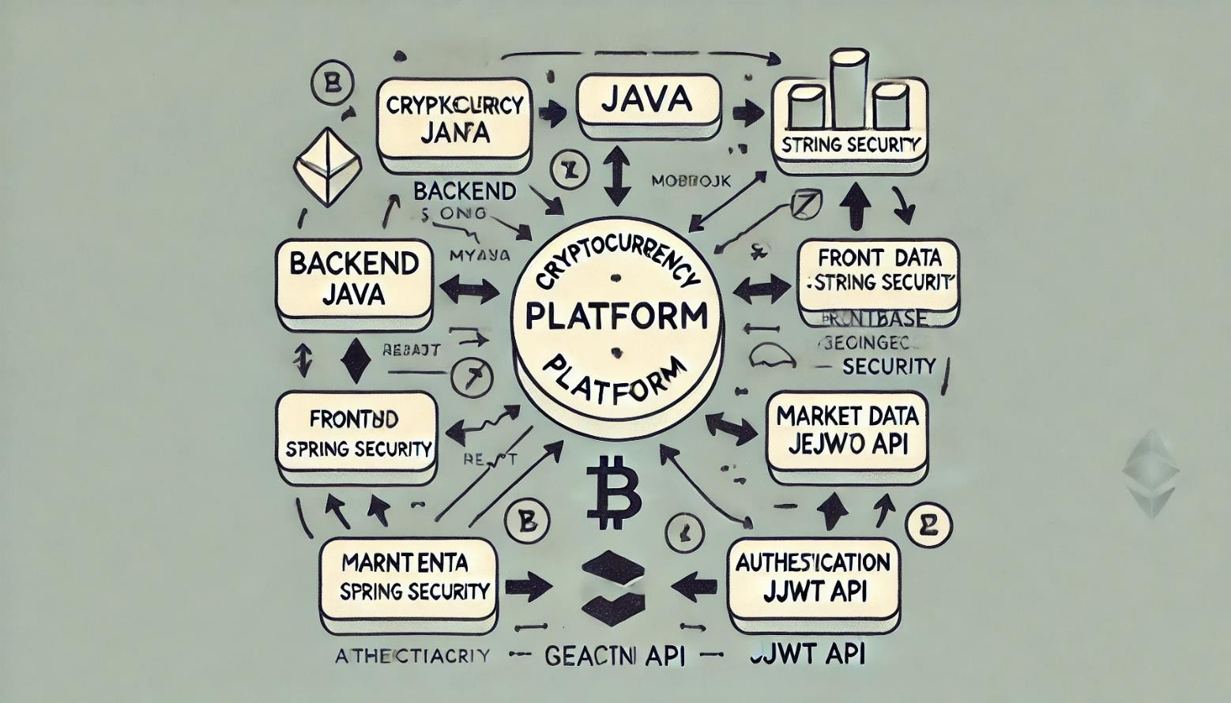

Figure 1: Working flow of project

The working flow of the cryptocurrency trading platform, as depicted in the diagram, begins with the user interacting with the frontend interface built with ReactJS. The central component of the platform is the Cryptocurrency Platform, which acts as the hub connecting all other modules. When a user logs in or registers, the platform communicates with the backend, powered by Java and Lombok, where user authentication is handled securely using Spring Security. Upon successful login, users are directed to the Dashboard, where they can view real-time cryptocurrency data.

The platform fetches the top 50 cryptocurrencies from external sources like CoinGecko API, displaying key information such as market cap, price, and volume in a user-friendly format. The Market Data module enables users to explore live data, while the Price Chart module, using Chart.js, visualizes cryptocurrency price trends over time. For executing trades, users can buy or sell cryptocurrencies, with all transactions being handled securely through Gemini API, which manages the actual trading functionality.

The platform also provides a Wallet feature that displays the user's balances and recent transaction history. For added security, JWT (JSON Web Tokens) are used for authentication, ensuring that only authorized users can access their account details and perform transactions. Additionally, a Chatbot module is integrated into the platform, allowing users to interact and inquire about cryptocurrency data or general platform queries. The entire frontend communicates with the backend and external APIs, ensuring smooth data flow, while the MySQL database stores user information, trading history, and wallet details, enabling the platform to function as a secure, real-time trading hub.

This working flow ensures that the platform is highly functional, interactive, and secure, providing a seamless experience for users interested in cryptocurrency trading.

#### 1.User Registration and Two Factor Authentication

User registration and two-factor authentication (2FA) help keep accounts safe on the platform. When a new user signs up, they provide their name, email, and password. This information is stored securely in the database. To make sure only the right person can access their account, the platform uses two-factor authentication (2FA). After entering their username and password, the user receives a one-time code (OTP) sent to their email. They need to enter this code on the platform to complete the login process. This extra step adds security by constant ensuring that even if someone knows the user’s password, they still can’t log in without otp. **Source Code:** formSchema = z.object({ email: z.string().email("Invalid email address"),

password: z.string().min(8, "Password must be at least 8 characters long"),

});

const LoginForm = () => { const navigate = useNavigate(); const dispatch = useDispatch();

const { auth } = useSelector((store) => store); const { toast } = useToast(); const form = useForm({ resolver: zodResolver(formSchema), defaultValues: { email: "", password: "",

},

});

const onSubmit = (data) => { data.navigate = navigate; dispatch(login(data)); console.log("login form", data);

}; return (

<div className="space-y-5">

<h1 className="text-center text-xl">Login</h1>

<Form {...form}>

<form onSubmit={form.handleSubmit(onSubmit)} className="space-y-4">

<FormField control={form.control} name="email" render={({ field }) => (

<FormItem>

<FormControl>

<Input

{...field}

className="border w-full border-gray-700 py-5 px-5" placeholder="enter your email"

/>

</FormControl>

<FormMessage />

</FormItem>

)}

/>

<FormField control={form.control} name="password" // Added password field render={({ field }) => (

<FormItem>

<FormControl>

<Input

{...field}

type="password" // Added type attribute for password input className="border w-full border-gray-700 py-5 px-5" placeholder="Enter your password"

/>

</FormControl>

<FormMessage />

</FormItem>

)}

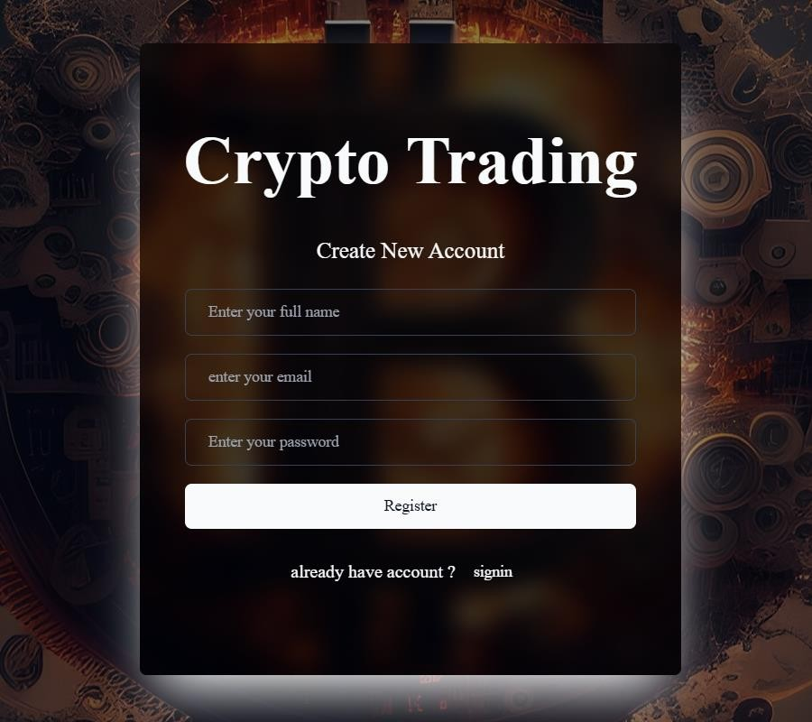

Figure 2: Registration Page

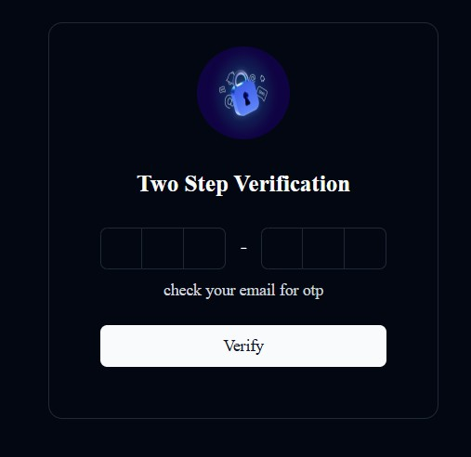

Figure 3: Two Step Verification

#### 2.Home Page

The home page of the cryptocurrency trading platform provides easy access to key features. After logging in, users can see real-time data of the top 50 cryptocurrencies, including price, market cap, and volume. It offers quick links to sections like market data, wallet management, and trading, where users can buy and sell cryptocurrencies. A chatbot is also available to assist with questions. The page is designed to be simple and user-friendly, making it easy for users to navigate and access all the important tools and information.

**Source Code for getting Market Data in Home Page:** import axios from 'axios';

export const dataType="Time Series (Daily)" const fetchData = async (keyword,symbol) => { try {

const response = await axios.get('https://www.alphavantage.co/query', { params: { function: keyword, symbol: symbol,

apikey: 'my api keyd', // Replace 'demo' with your actual API key market:"EUR"

}

});

// Check if data was retrieved successfully if (response.status === 200) { return response.data; // Return the data

} else { throw new Error('Failed to fetch data');

}

} catch (error) { console.error('Error fetching data:', error); return null; // Return null if there's an error

}

};

export default fetchData;

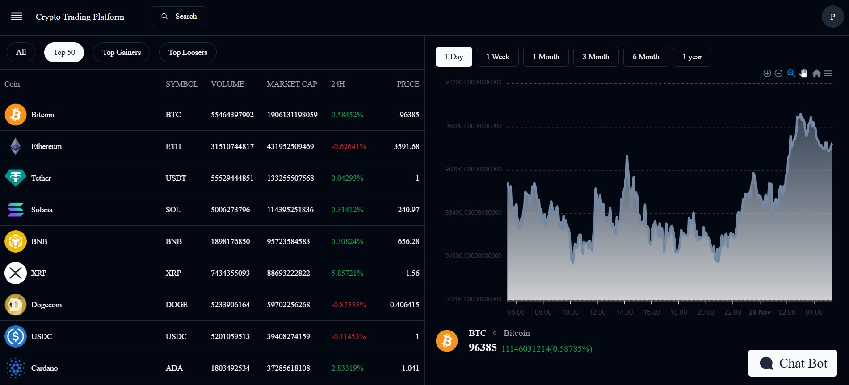

Figure 4: Home Page

**Module 3**

### Module-3.2: Backend Implementation

**Working Flow Of Backend:**

The backend of the cryptocurrency trading platform is built using Spring Boot, handling the core logic, database interactions, and API integrations. The flow starts when a user attempts to log in or register on the platform. First, their credentials are verified through Spring Security to ensure only authorized access. During registration, the user's details are stored securely in the MySQL database.

Once logged in, the backend manages data retrieval, such as fetching real-time cryptocurrency data from the CoinGecko API. This data is processed and sent to the frontend, where it’s displayed in user-friendly charts and tables. For trading, when a user decides to buy or sell a cryptocurrency, the backend interacts with the Gemini API to perform the trade securely, updating the user's wallet and transaction history in the database.

The backend also handles JWT (JSON Web Tokens) for secure user authentication, ensuring that each request is validated. The user's wallet, transaction history, and balances are regularly updated in the database to reflect any changes from their trading activities. Additionally, the platform integrates a chatbot API to handle user queries related to cryptocurrencies or account information, providing real-time support.

Overall, the backend is responsible for managing user data, fetching market information, processing transactions, ensuring security, and handling all interactions between the user and external APIs.

**Components in Backend:**

* Authentication and Authorization (Spring Security) o User Management (MySQL Database) o Cryptocurrency Data Service (API Integration)

* API Gateway and Communication o Chatbot (API Integration)
* Security & Data Protection

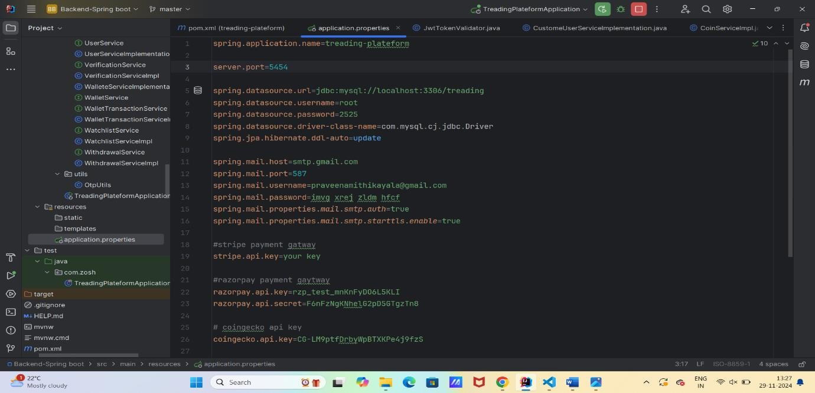

Figure 5: Application Properties

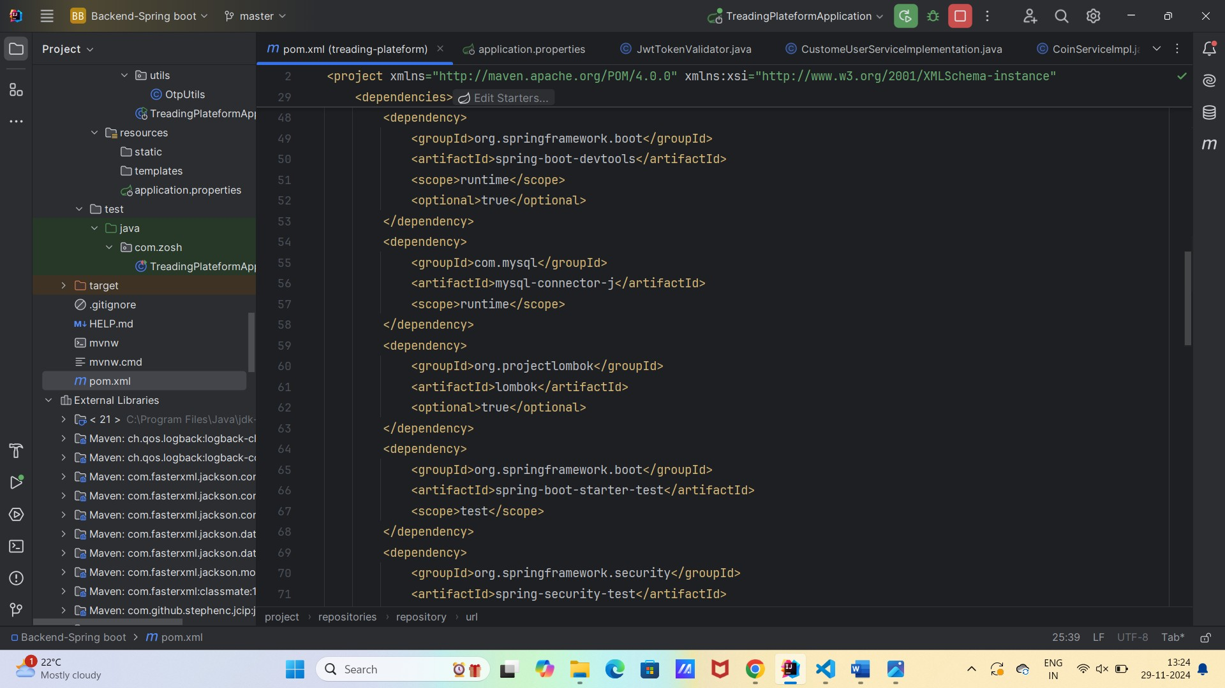

Figure 6: Backend Dependency

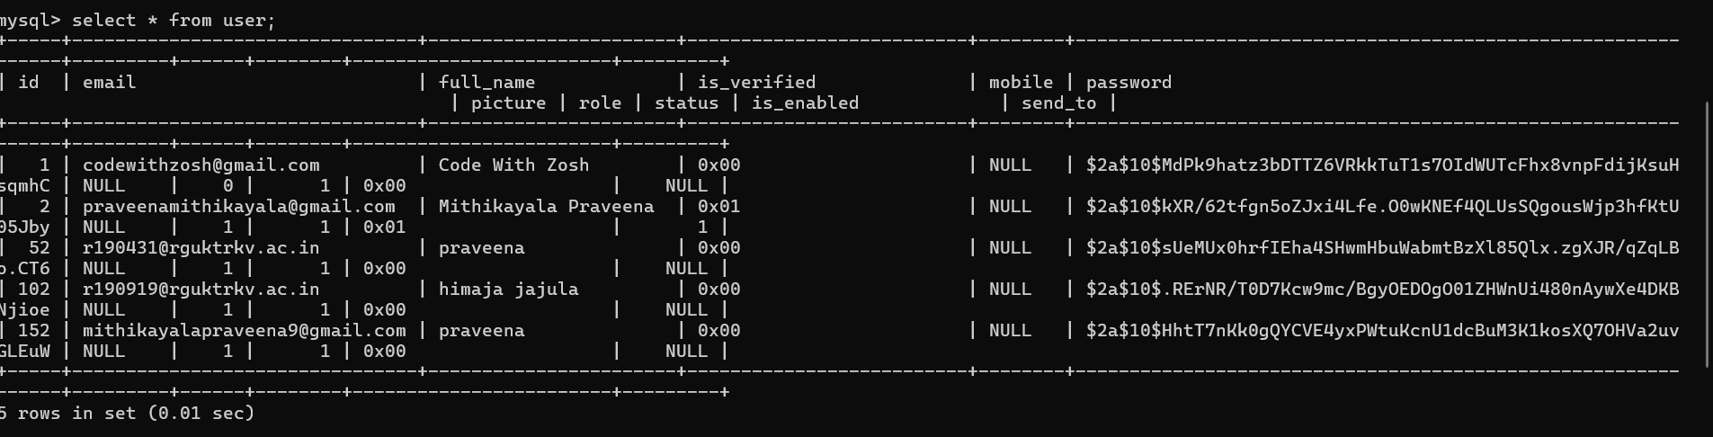

Figure 7: User Table

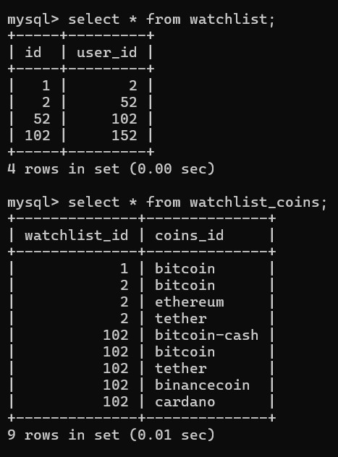

Figure 8: Watchlist

### Results and Discussion

The cryptocurrency trading platform successfully integrates various components to provide users with a seamless trading experience. The implementation of real-time market data from the CoinGecko API allowed users to view the top 50 cryptocurrencies along with their market cap, price, and trading volume. Price fluctuations were displayed effectively through interactive charts powered by Chart.js, offering users an intuitive way to track market trends. The trading functionality worked smoothly with the Gemini API, enabling users to buy and sell cryptocurrencies securely, while their wallet balances and transaction history were updated instantly. Additionally, the two-factor authentication (2FA) system, which utilizes OTPs, added an essential layer of security, ensuring that only authorized users could access their accounts.

The chatbot feature also proved to be a valuable addition to the platform. It provided real-time support to users, answering questions related to cryptocurrencies and the platform’s features. This interactive feature contributed to a more engaging user experience, as users could quickly get answers to common queries without the need for human intervention. The integration of JWT (JSON Web Tokens) for secure session management worked flawlessly, ensuring that user data and transactions remained protected throughout their interaction with the platform. Overall, the platform successfully achieved its primary goal of creating a secure, efficient, and user-friendly environment for cryptocurrency trading.

### Discussion

While the platform achieved its core objectives, there were areas where further enhancements could improve user experience and functionality. For instance, while the real-time cryptocurrency data was reliable, there were occasional delays in fetching data during periods of high traffic. This could be mitigated by implementing more efficient caching strategies or by integrating additional data sources for redundancy. The trading execution process using the Gemini API was effective but could be further optimized by adding features like price alerts or automated trading based on specific conditions, which would provide users with a more personalized trading experience.

In terms of security, the integration of two-factor authentication (2FA) and JWT enhanced the platform's protection against unauthorized access. However, as cryptocurrency trading involves sensitive financial transactions, future improvements could include advanced encryption techniques or multi-signature authentication for added layers of security. Additionally, the chatbot feature, while helpful, could be expanded with AI-driven responses to handle more complex user queries. By continuously updating the platform with new features, optimizing performance, and maintaining high security, the platform could better serve the growing demand for cryptocurrency trading.

**Conclusion and Future Enhancement**

The cryptocurrency trading platform successfully meets its objectives of providing a secure, user-friendly environment for trading digital currencies. With real-time market data, seamless buying and selling functionalities, and an intuitive user interface, it enables users to interact with the cryptocurrency market effectively. The integration of features such as twofactor authentication (2FA), secure session management with JWT, and a chatbot for real-time assistance ensures that the platform remains both secure and responsive. The implementation of the CoinGecko API and Gemini API provided reliable market data and secure trade execution, making the platform functional and efficient for cryptocurrency traders. Overall, this project highlights the potential for combining modern web technologies to create a comprehensive and secure cryptocurrency trading solution.

While the platform has achieved its primary objectives, there are several potential enhancements that could improve both the user experience and overall functionality. One key improvement could be the addition of real-time price alerts and automated trading features, allowing users to set personalized conditions for buying or selling cryptocurrencies based on price movements. Furthermore, the chatbot can be enhanced with AI-driven natural language processing (NLP) to handle more complex user queries and provide even more personalized assistance.

|  |  |
| --- | --- |
|  | **REFERENCES**    CoinGecko API Documentation : https://www.coingecko.com/en/api  Gemini API Documentation : https://gemini.com/api  Spring Boot Documentation : <https://spring.io/projects/spring-boot>  Spring Security Documentation : <https://spring.io/projects/spring-security>  JWT (JSON Web Token) Overview : https://jwt.io/introduction/  Chart.js Documentation : https://www.chartjs.org/docs/latest/  React.js Documentation : https://reactjs.org/docs/getting-started.html  MySQL Documentation : <https://dev.mysql.com/doc/>  Lombok Documentation : <https://projectlombok.org/>  OpenAI Chatbot (GPT) Model Overview. (2023). <https://openai.com/chatgpt>  Cryptocurrency Security Best Practices. (2021). *Bitcoin Magazine*. https://bitcoinmagazine.com/guides/security  React.js Documentation: https://reactjs.org/docs/getting-started.htm |
| **3** | |